Problem Time: 30 min

Snapshots:

is_perfect_square function checks whether the given number is a perfect square or not (NB: number is a perfect square if it can be expressed as the square of an integer) hence, this function takes as a parameter the number user wants to check and in while loop if there is an int i such that (i * i = number) this number is a perfect square so return 1 (represents true) otherwise return 0 (represents false).

reverse_digits function takes as a parameter the number the user wants to reverse then in a while loop get the last digit in each iteration by using the % operator and then multiply the reversed number by 10 (that will make the reversed number contain 0 as a last digit) A computer screen with colorful text
after that add this reversed number to the digit you obtain from the previous line of code and finally divide the number by 10. continue this operation until the number becomes 0.

sum_digits function takes as a parameter the number you want to some digits of and then in a while loop gets the last digit in each iteration by using the % operator like the previous function and adds that digit to the sum variable and finally divides the number by 10. continue this operation until the number becomes 0.

in the main function we ask the user for a positive number and if the number is negative then terminate the program with a message to the user otherwise, we check if the number is a perfect square using our function and display a message to the user tell him what the result is then use our functions to reverse the number and add its digits and display the results to the user.

Test cases:

for ex. the number is 12345 (not a perfect square)

for ex. the number is 144 (a perfect square)

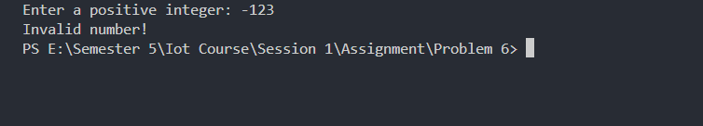

in case the number is negative the problem will be terminated

Algorithm:

Step 1: Read the number from the user

Step 2: Check that the number is positive value if not terminate the program with a message to the user telling him that the number is invalid

Step 3: Check if the number is perfect square or not using is_perfect_square this function returns 1 if that’s true otherwise returns 0 and then display a message to the user.

Step 4: Reverse the number using reverse_digits function and display the reversed number

Step 5: Sum all digits in the number using sum_digits function and display the sum